

** TOUR AND TRAVEL BOOKING SYSTEM**

**PROJECT MEMBERS**

Kaniesh Raj R - 23CDR064

Logeshwar KS - 23CDR079

Date:13/05/2025



The manual process of booking tours and managing travel services is

time-consuming and error-prone. Customers struggle with limited access to real-time information and secure bookings. Travel agencies lack efficient tools for managing operations. A centralized system is needed to streamline bookings, payments, and communication for better user experience.

# Solution

A Tour and Travel Booking Management System will automate booking, payment, and itinerary processes. It will provide real-time package availability, secure transactions, and customer support. Travel agencies can manage bookings, customer data, and updates efficiently. The system ensures a smoother, faster, and more reliable travel experience for all users.

3

# Website workflow diagram

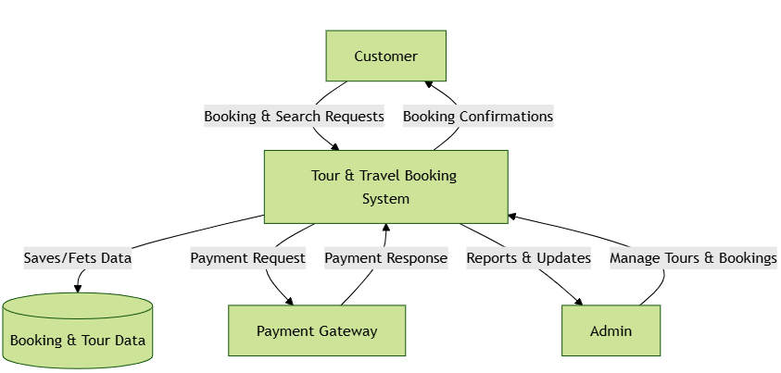

4

**Entity Relationship diagram**

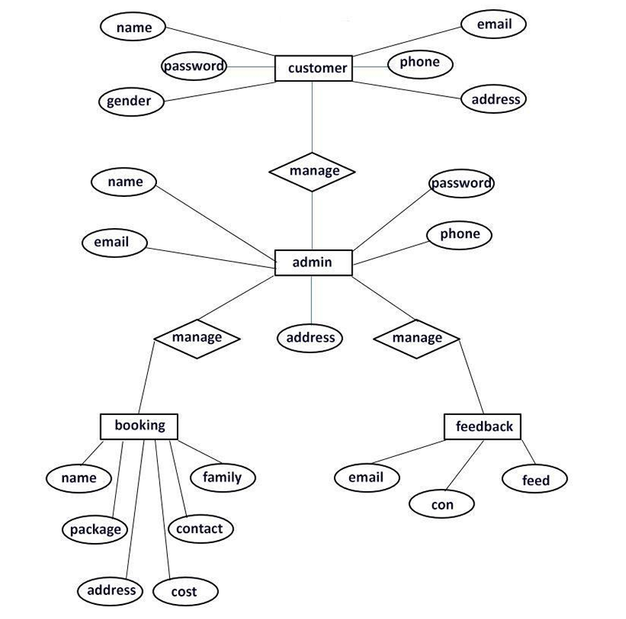

5

# Tables description

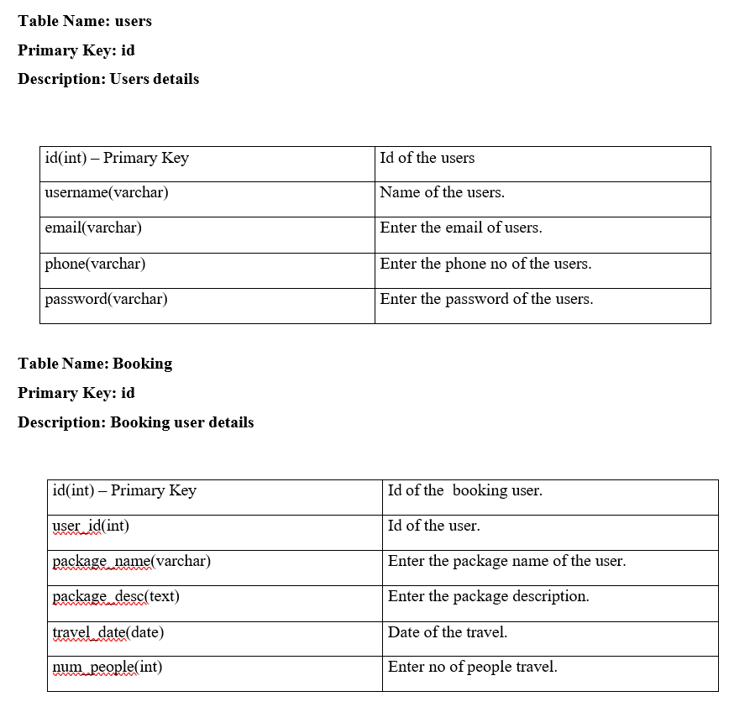

6

# Tables description

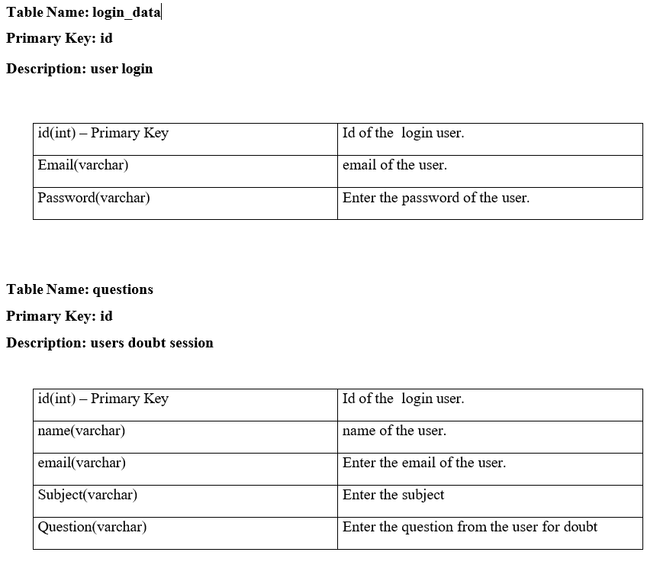

7

# Software / Hardware Tools used

* HTML
* CSS
* PHP
* JAVA SCRIPT
* sqlite

8

# Input and Output

* Home page opens up immediately

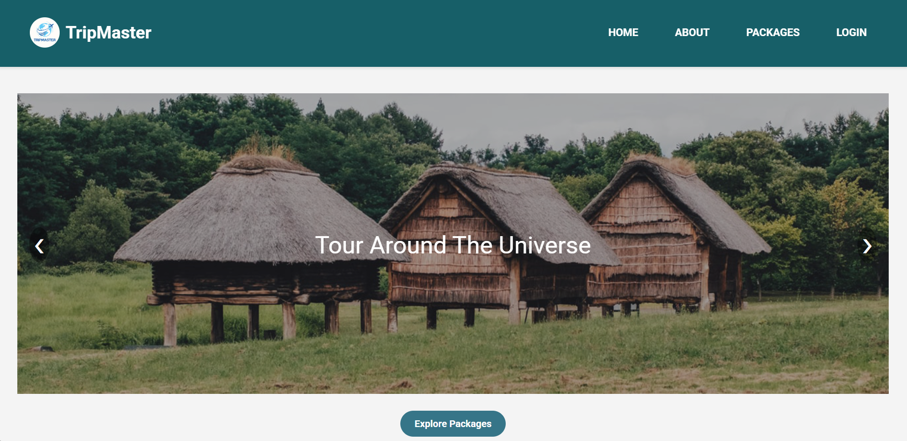u

9

* + Booking the Tour And Travel Details

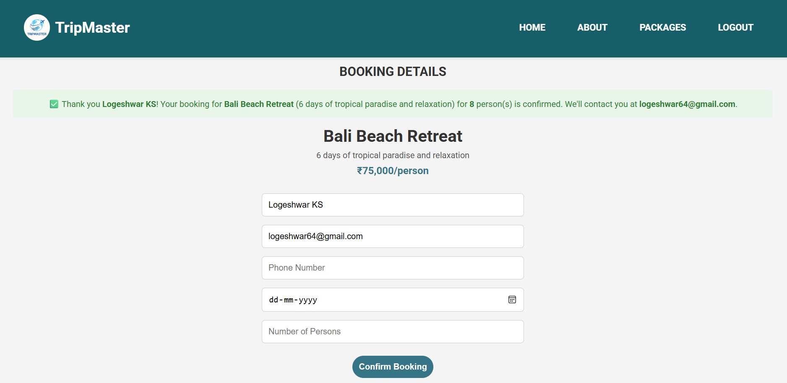



10

* + Tour and Travel Booking Locations



11

* This is the database contains bookings table

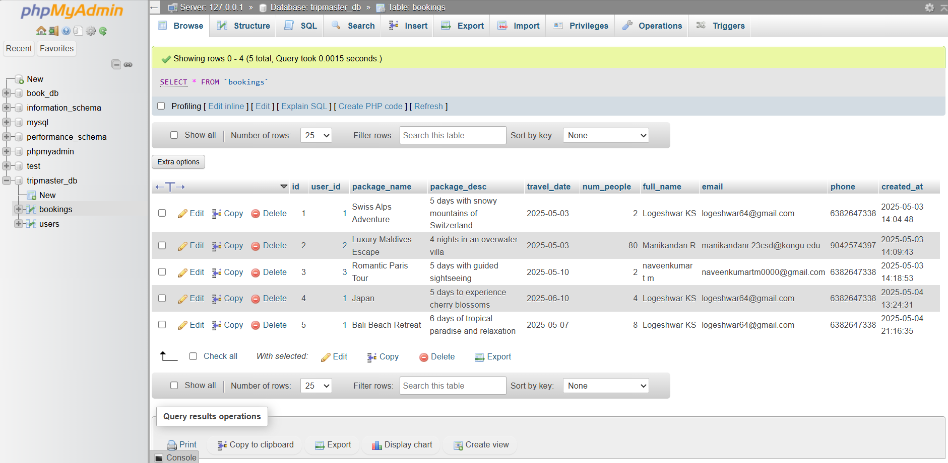

12

# Conclusion



The Tour and Travel Booking Management System effectively addresses the limitations of traditional, manual systems by introducing automation and centralized data management into travel agency operations. Through this system, travel agents and customers can efficiently manage the entire booking process—from browsing packages to making payments—thereby enhancing both internal efficiency and customer satisfaction.

 **Thank you!**